Chapter 1 Introduction

The motive of this project is to develop a full fledged server with support to latest technologies developing in the market. That is -

- Provide IoT support
- Provide cloud support
- Provide machine leaning and artificial intelligence support

It combines technologies of various fields into a one unique machine. Use of various programming languages is take like -

- Python
- C ++
- C
- Java
- Bash scripts/Terminal scripting
- MySQL query language
- HTML

IoT helps in interfacing the virtual world with the physical world, while generating enormous amount of data which can be stored inside the cloud server and proper and easy LAN and WAN access of that data is made possible only with the help of cloud server. While the generated data need to be processed to fetch some meaning and value to the business which is supported with the help of technology called machine leaning and artificial intelligence.

Python is used to create bash scripts and implement the technology of computer vision in this project while C and C++ is used to program the micro controllers.

HTML, JAVA, MySQL and others are used to develop the web interface to provide user support and make the server capable of data protection, access and user credential protection.

The motive of this project is to make a wast scope idea that have its implementation in day to day life by providing and easy mind controlled appliance that allow user to control the power of appliance just by thinking by using EEG, computer vision and IoT.

Second motive of this project is to allow speech controlled environment for have, provide security and real time surveillance to each and every home and provisioning a secure way of data access i.e a self hosted cloud in a cheap yet affective way.
Chapter 1.1 Server Side Utilities

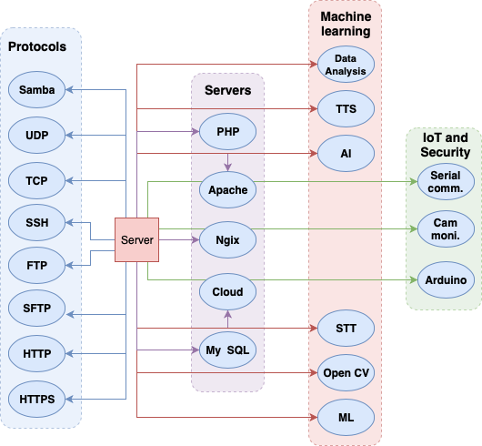

Figure 1.1 Utilities and facilities running on server

Server side is consist of 4 different parts i.e
- Protocols
- Servers technologies
- Machine Learning and AI based technologies
- IoT and Security Technologies

Protocol – These are the set of rules that are used to implement various technologies for the management and controlling the working of various services inside the server side. Like MIME for email service activation as soon as the server starts, a cloud server scripts begin to run that takes screen short of the screen and send the created screen capture to defined email using MIME protocol. SSH is used to login remotely and etc.

Server Technologies – This contains various different technologies from different vendors which when combined provides services of website hosting, database management, controlling and file access.

Machine Learning and AI based technologies – These contains technologies related to artificial intelligence and machine learning. From speech to text conversion, to text to speech conversion, detection of objects, human faces, posture and movement is managed by this field only, it also provides data analysis and visualisation for the generated data.

IoT and Security Technologies – These contains using the latest technologies like IoT i.e internet of things. It helps in automated heat management of the system, remotely controlling devices and appliances, to authentication using RFIDs, It uses microcontrollers like raspberry pi and arduino with several sensors connected to it.

As shown in figure 1.1, left side shows 8 protocols running:
- Samba
- UDP
- TCP
- SSH
- FTP
- SFTP
- HTTP
- HTTPS

Samba – It is used to create a NAS storage at the LAN level to support a simple file accessing system using Samba protocol to the mounted drives attached to the storage.

UDP – It is a fast data transfer protocol, that sends data without expecting a acknowledgment hence making the process fast, and is used mostly for vide streaming where few lost package does not destroy the integrity of the data.

TCP – On the other hand TCP waits for the acknowledgement after the transfer of package from one user to another and is used to transfer data like documents, and data whose integrity is crucial. It is slow but no data is lost as the lost data is sent again if no acknowledgment is recieved.

SSH – Secure shell is used to remotely login into the system and access the system using the shell i.e terminal in Linux and OSX and powershell in windows. It uses port 22.

FTP – File transfer protocol as the name suggest is used to transfer file between two remotely located but interconnected over network systems. Samba is freely available, unlike other SMB/CIFS implementations, and allows for interoperability between Linux/Unix servers and Windows-based clients. File Transfer Protocol (FTP) is a standard network protocol used to exchange and manipulate files over a TCP/IP based network, such as the Internet.

SFTP – Shell file transfer protocol, uses SSH protocol for the transfer of file between two remote systems.

HTTP – Is an old protocol used to display websites, locally port 80 is open and is allowed by the firewall to make and accept request on the internet.

HTTPS – Is a secure HTTP protocol, Instead of HyperText Transfer Protocol (HTTP), the website uses HyperText Transfer Protocol Secure (HTTPS). Using HTTPS, the computers agree on a "code" between them, and then they scramble the messages using that "code" so that no one in between can read them. This keeps your information safe from hackers. They use the "code" on a Secure Sockets Layer (SSL), sometimes called Transport Layer Security (TLS) to send the information back and forth.

MIME – MIME (Multi-Purpose Internet Mail Extensions) is an extension of the original Internet e-mailprotocol that lets people use the protocol to exchange different kinds of data files on the Internet: audio, video, images, application programs, and other kinds, as well as the ASCII text handled in the original protocol, the Simple Mail Transport Protocol (SMTP). In 1991, Nathan Borenstein of Bellcore proposed to the IETF that SMTP be extended so that Internet (but mainly Web) clients and servers could recognize and handle other kinds of data than ASCII text. As a result, new file types were added to "mail" as a supported Internet Protocol file type.

Figure 1.1, shows 5 servers running:
- PHP
- Apache
- Ngix
- Cloud
- My SQL

PHP – PHP is a general-purpose scripting language that is especially suited to server-side web development, in which case PHP generally runs on a web server. Any PHP code in a requested file is executed by the PHP runtime, usually to create dynamic web page content or dynamic images used on websites or elsewhere.

Apache – Apache is the most widely used web server software. Developed and maintained by Apache Software Foundation, Apache is an open source software available for free. It runs on 67% of all webservers in the world. It is fast, reliable, and secure.

Nginx – The NGINX web server can act as a very capable software load balancer, in addition to its more traditional roles serving static content over HTTP and dynamic content using FastCGI handlers for scripts. Because NGINX uses a non-threaded, event-driven architecture, it is able to outperform web servers like Apache.

Cloud – The cloud server is based on Google Driver type technology which is called nextCloud a fork that developed from ownCloud is used for easy drag and drop cloud based technologies which support various features like, social networking, video calling, device tracking, office document editing and management, note taking, etc. The cloud server uses PHP, My SQL and Apache server and is hosted on port 80 i.e HTTP and HTTPS is used.

My SQL – It is based on a client-server model. The core of MySQL is MySQL server, which handles all of the database instructions (or commands). MySQL servers available as a separate program for use in a client-server networked environment and as a library that can be embedded (or linked) into separate applications.

Figure 1.1, shows 6 ML and AI facilities running:
- Data Analysis
- TTS
- STT
- AI
- Open CV
- ML

Data Analysis – Data analysis can be performed with the help of pre designed scripts developed in python programming language and combined with the bash shell scripts just requires the input of data as the argument along with the input hence making a robust and easy to maintain and modify with changes in future.

TTS – Text to speech is also performed as the user speaks that spoken language is analysed with the help of speech to text technology and that text is transferred over network to the local server for processing in the voice command script. Full description of the functioning will be provided in further document.

STT – Speech to text, this technology is being used at both client and server. When client provides a predefined command to the machine by running the hello.py script in python language that first asks for the host or server IP address that is running the analysis for the converted speech to text and then the commanded task is performed. Full description of the functioning will be provided in further document.

AI – Artificial in itself is a very wide and vast topic and high level implementation requires better processing power. But due to the limited processing power and working in the ability of the knowledge AI here is used for training the Open CV models hence help in creation of harcascades for face detection and object detection that takes input in form of 10000 test cases consisting of several images.

Open CV – It is a well known image processing library that supports from small objects a like microbes to huge objects like starts and planets. Here the used Open CV library are of volume 3 and volume 4. It is used for object and face detection based on the machine and server trained xml(s) of harrcascades.

ML – Machine leaning technology is used in machine in form of data visualisation for the creation of graphs and predication modles.

Figure 1.1, shows 3 IoT and Security facilities running:
- Serial Communication
- Monitoring over webcam
- Arduino dev/ttyACM0

Serial Communication – The server hosting hardware is connected to the small microcontrollers like arduino which are connected to the sensors and the server is directly controlling those microcontrollers using serial ports of USB 2.0. All the data received is stored into data files and serial in opened to send and receive data for commanding and performing tasks in physical world. Serial communication here is a true interface between the software and the physical world.

Monitoring over webcam – The server provides security in form of real time surveillance and monitoring using the usb 2.0 webcam attached to one of its serial port. The webcam surveillance uses the port 8080 of the local host which when exposed to public IP helps in proper monitoring of the surroundings inside the local network or over WAN.

Arduino – dev/ttyACM0 is the port to which arduino number one is connected which transfers data related to heat of the system, controlling fans and lights and appliance connected to it using and relay, humidity details and PM 2.5 details.
Chapter 1.2 Server Side open ports
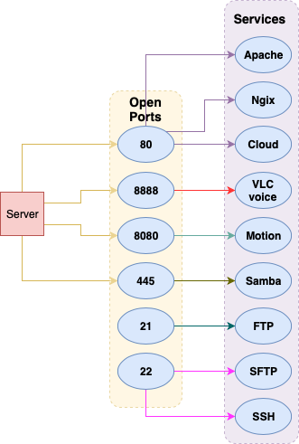
Figure 1.2 open port available on server side

Figure 1.2. shows, server side is consist of 4 different parts i.e
- 80
- 8888
- 8080
- 445
- 21
- 22

Port 80 – It is used mainly for the internet, and all the request from and to internet goes through port 80. most of the firewall allow the request from port 80 and is open by default. It uses protocols like http and https. Here in the project port 80 is used for hosting servers like Apache and Nginx. While the cloud storage hosted on Apache can also be easily accessed over this port 80.

Port 8888 – This port is opened when a script is run accessed using ssh, as soon as the scripts run it open a port on the remote server playing an MP3 file as out.mp3. Which is basically outputting the sound which is being heard by the speakers connected to the servers hardware allowing to hear what is all playing onto and around the server.

Port 8080 – It opens a motion service. When motion service is started using ‘sudo service motion start’ command onto the server shell, it activates the webcam which can be seen on the remote servers port 8080. Can be accessed using a web browsers as ‘Servers.ip.address.inbrowser:8080’.

Port 445 – Samba service for file management is hosted onto the port 445, which gives the server a unique open port that allow the bind drives to the server to be accessed remotely inside the LAN and can be used to access over WAN, if the local host have a public domain attached to it. t is used to create a NAS storage at the LAN level to support a simple file accessing system using Samba protocol to the mounted drives attached to the storage.

Port 21 – Port 21 is famously known for service of FTP. File transfer protocol as the name suggest is used to transfer file between two remotely located but interconnected over network systems. Samba is freely available, unlike other SMB/CIFS implementations, and allows for interoperability between Linux/Unix servers and Windows-based clients. File Transfer Protocol (FTP) is a standard network protocol used to exchange and manipulate files over a TCP/IP based network, such as the Internet.

Port 22 – SSH service uses this port 22 to allow remote login to the server from anywhere and from any client machine inside the LAN or over WAN if the server ip is forwarded to some public domain or Public IP. Secure shell is used to remotely login into the system and access the system using the shell i.e terminal in Linux and OSX and powershell in windows. hell file transfer protocol, uses SSH protocol for the transfer of file between two remote systems.

Chapter 1.3 Voice control

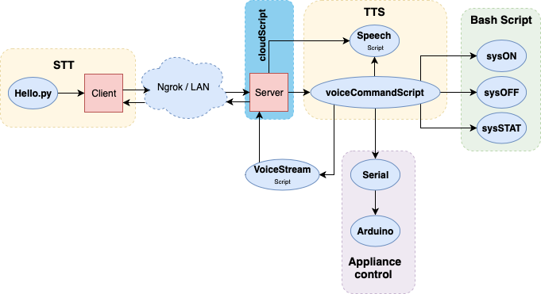

Figure 1.3 Voice control mechanism

Figure 1.3 show the complete flow of the voice control mechanism followed between client and server.

The complete architecture for voice control is divided into 7 components, all the components have sub parts inside it. Those parts are -

- STT
- Interconnection (Nrgrok/LAN)
- CloudScript
- TTS
- Bash Scripts
- Application Control
- VoiceStream script

STT – Client running the provided python script called hello.py inside the python 3 environment, while being connected to the internet the client can communicate and command the remote server with his speech using the speech to text conversion.

Interconnection (Nrgrok/LAN) – This explains how the internconnection or the communication will establish between the client and the server. It uses two ways of establishing the connection i.e -
- Locally – LAN – Inside the same network of the router having common gateway and starting class C IP address, which support 254 hosts.
- Globally – Ngrok – It is a free plan service which helps in forwarding a local machine to a port hosted by the ngrok servers, hence allowing easy access to local machine globally from anywhere without having the need to forward port on the router device.

The ngrok uses commands like:
- ngrok tcp 22
- ngrok http 80
- ngrok start –all
The file for configuration is located at /home/pi/.ngrok2/ngrok.yml and is edited using sudo nano and is as shown in figure 1.4

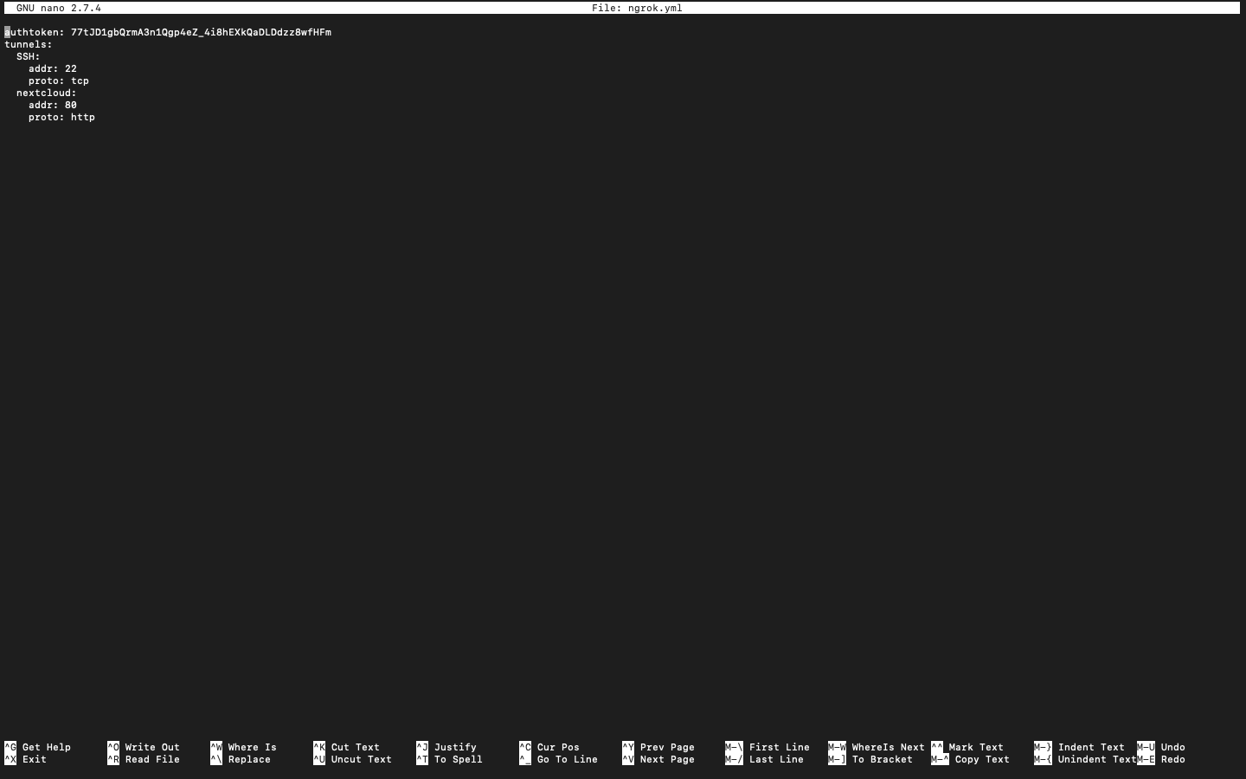
Figure 1.4 ngrok configuration file

CloudScript – This script is saved in bin location and changed mode using ‘chmod 755 filename’ to executable form so this bash script can easily be executed using a single command called cloudScripts. This command called ‘cloudScript’ is then saved into the ‘bashrc’ file, using command ‘nano ~/.bashrc’. So this makes the cloudScript to run by default as soon as the terminal opens. Now the terminal is made to open by default as soon as the server starts and login into the operating system.

The cloudScript looks like as shown in figure 1.5:
- First the script is converted to a bash file so the terminal can know that it is an executable type of file. This is done by using #!/bin/bash
- a file variable is created with the location of a file in it called cloudScript.temp which is a temporary file that prevents the re-execution of the cloudScript so only one instance creates for a session.
- Later that file is tested using if-then else condition for the existence of the file.
- If file do not exist then a file is existed and a line is echoed saying “[WARNING] ngrok Instance created, Please do not delete it.
- And the programs wait for creation by sleeping for 2 seconds.
- Then method of parallel exicution of command is used using & p(n) = $(n), where (n) is an integer number matching the number of command and later the execution is killed using [ "$?" -gt 1 ] || exit "$p(n)" .
- Screen short is taken using ‘import -window root filenage.png’ and saved in a location.
- That screen short is then mailed using the script created in python to the specified email address telling the ngrok instance address so that can be accessed using web browser or the terminal to ssh in the remote machine.
- The mailing script developed in python is shown in figure 1.6(a) and 1.6(b).
- Another script called RebootScript is created which whose only motive is to remove the png screen capture and the temp file of cloudScript so a new ngrok instance can be created.
- This file is then made to execute as soon as the os boots and is achieved using ‘sudo update-rc.d NameOfTheScript defaults’ command in the terminal.
- Saving the file in init.d allow the script to be controlled using a single turn ON and OFF commands:

  - sudo /etc/init.d/NameOfTheScript start
  - sudo /etc/init.d/NameOfTheScript start

- This helps in making the robust and smart and a complete black box which allow a simple power ON and OFF mechanism and the user do not have to worry about what is going inside the server as server manages it self.

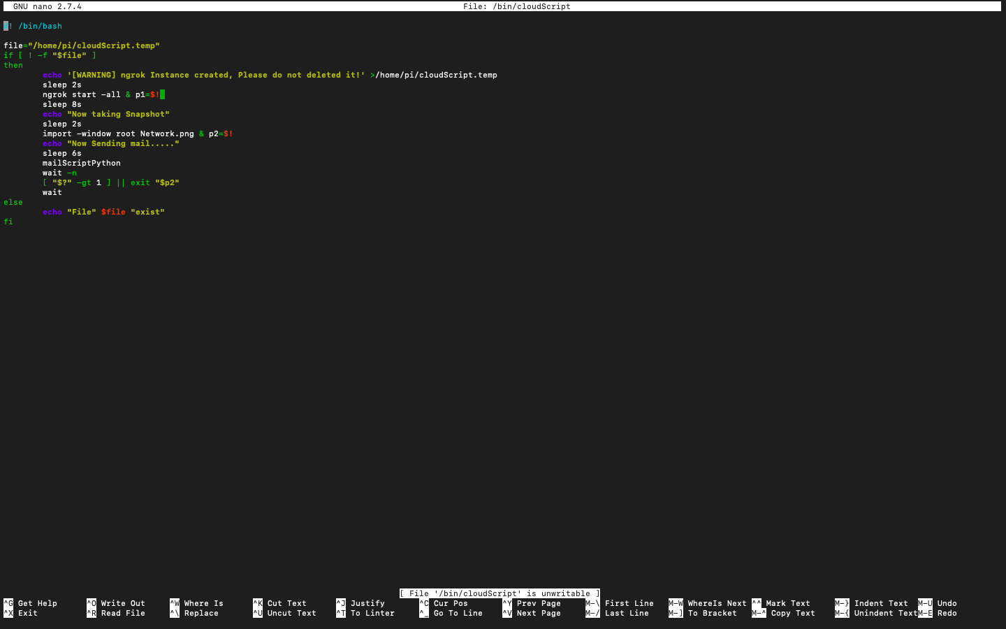
Figure 1.5 cloudScript

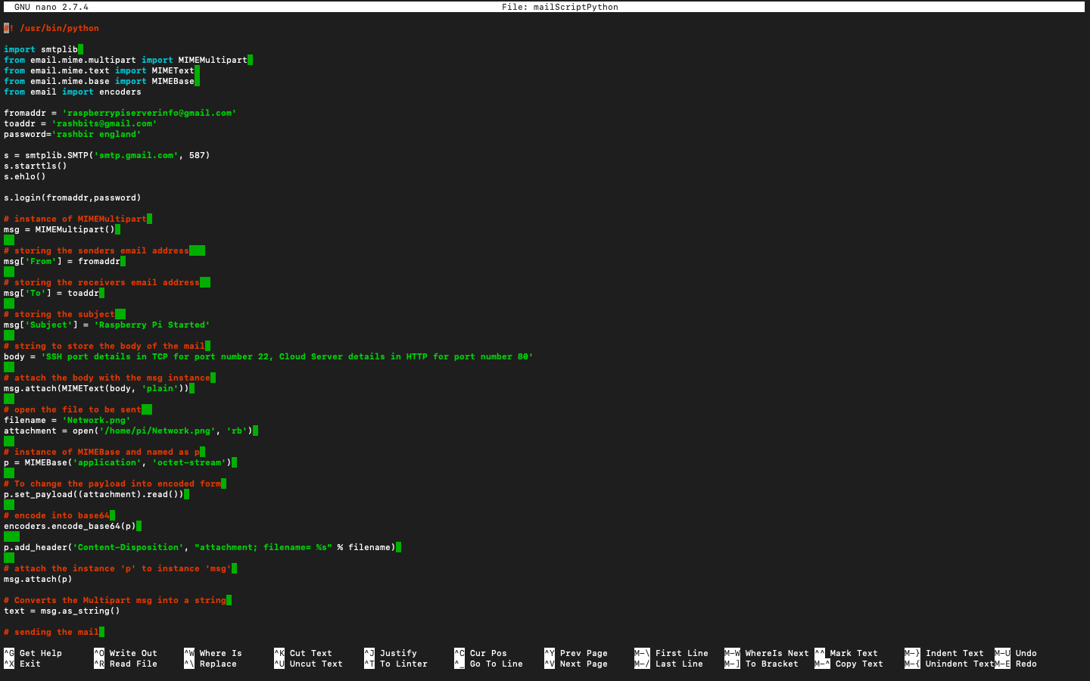
Figure 1.6(a) mailScriptPython

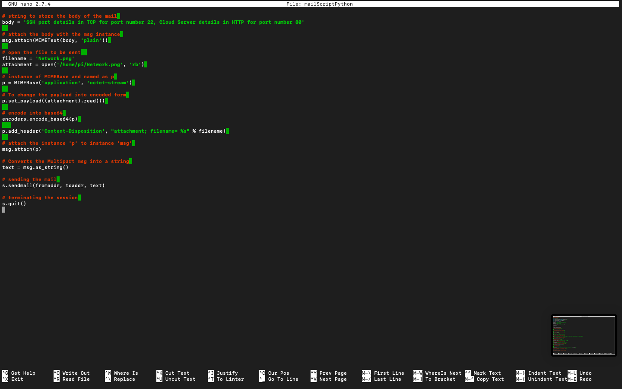
Figure 1.6(b) mailScriptPython

TTS – The text to speech conversition is done and commands are executed as programmed. The script for the command can be sheen in :
- Figure 1.7(a) i.e voiceCommandScript
- Figure 1.7(b) i.e Speak script
- 1.7(c), 1.7(d) and 1.7(e) i.e simple_google_tts script

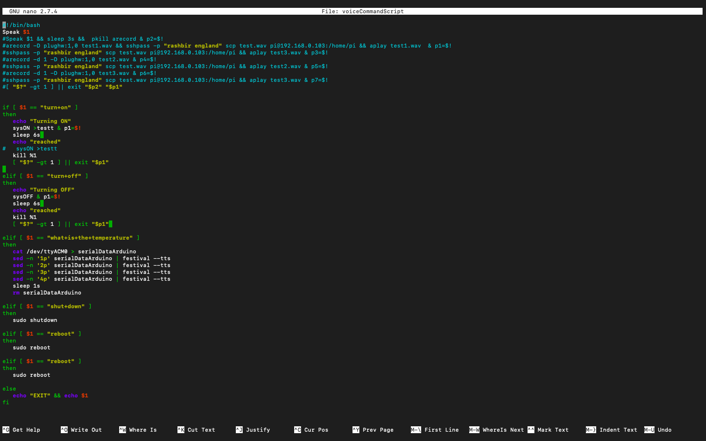
Figure 1.7(a) voiceCommandScript

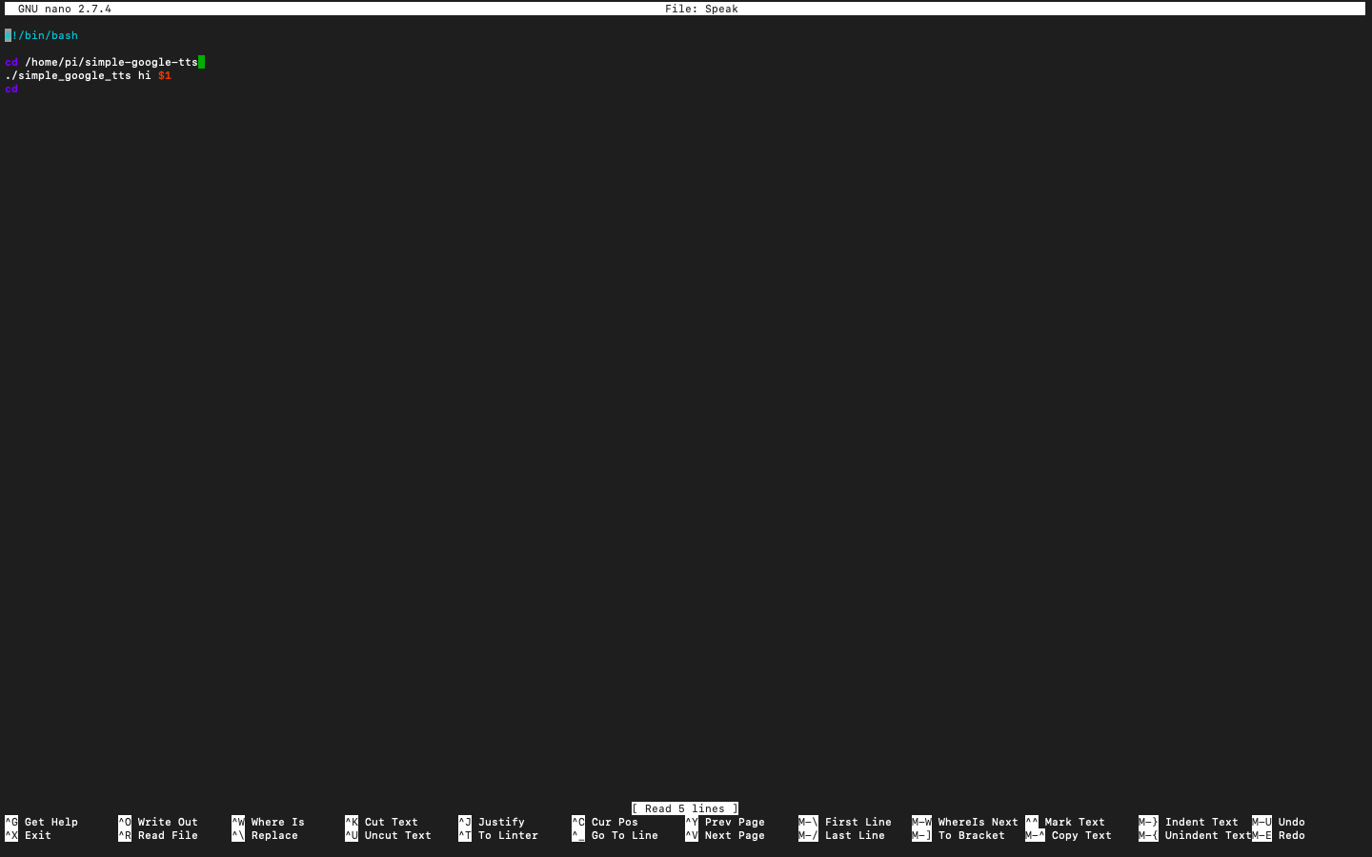
Figure 1.7(a) Speak
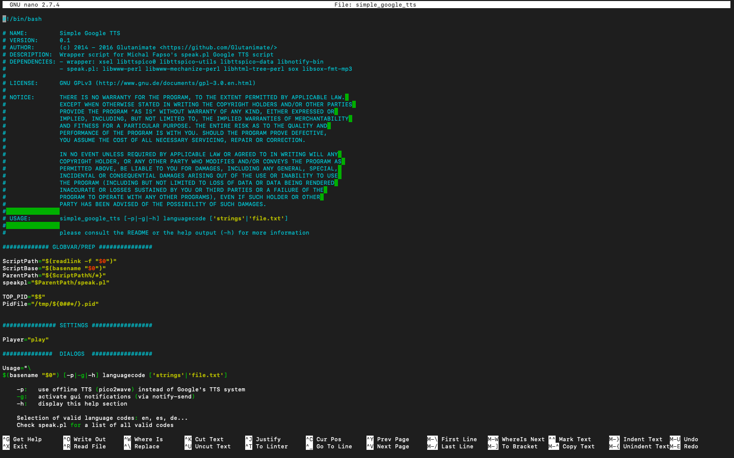
Figure 1.7(c) simple_google_tts

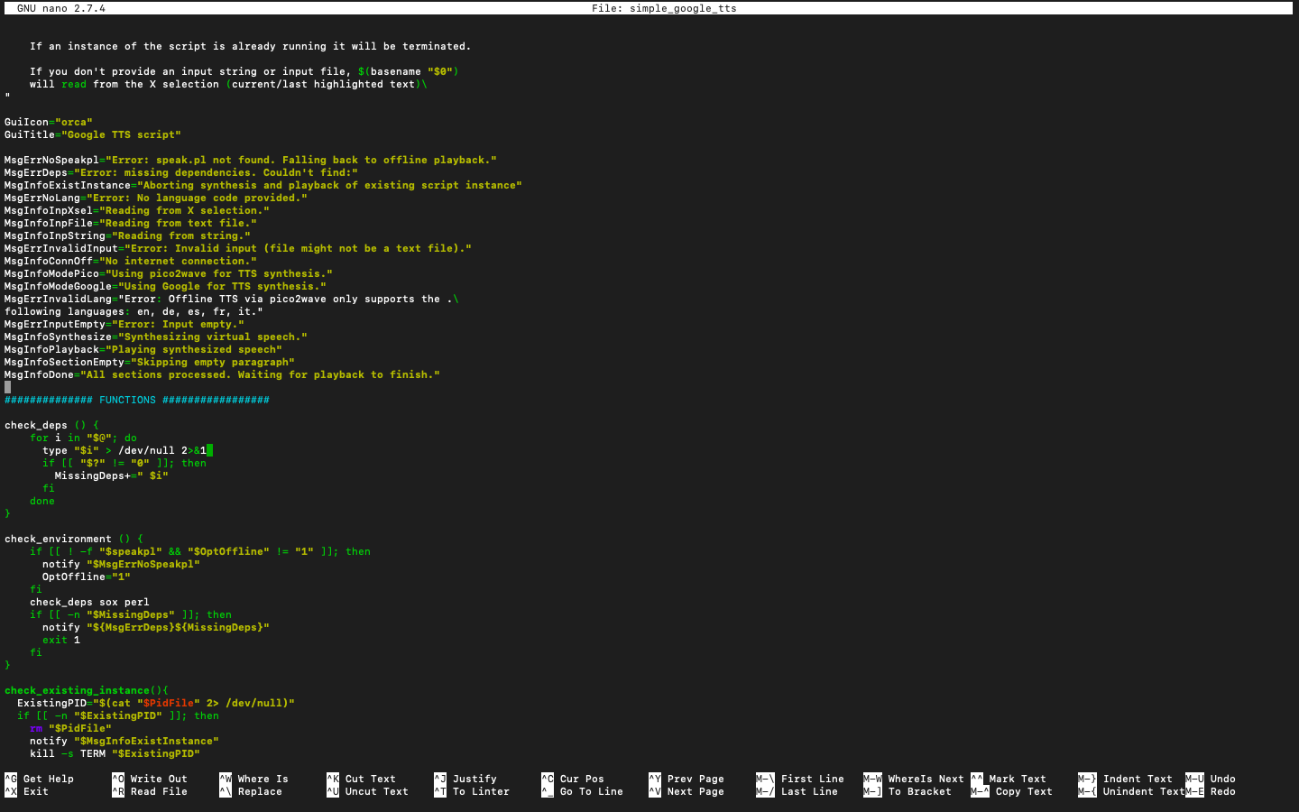
Figure 1.7(d) simple_google_tts

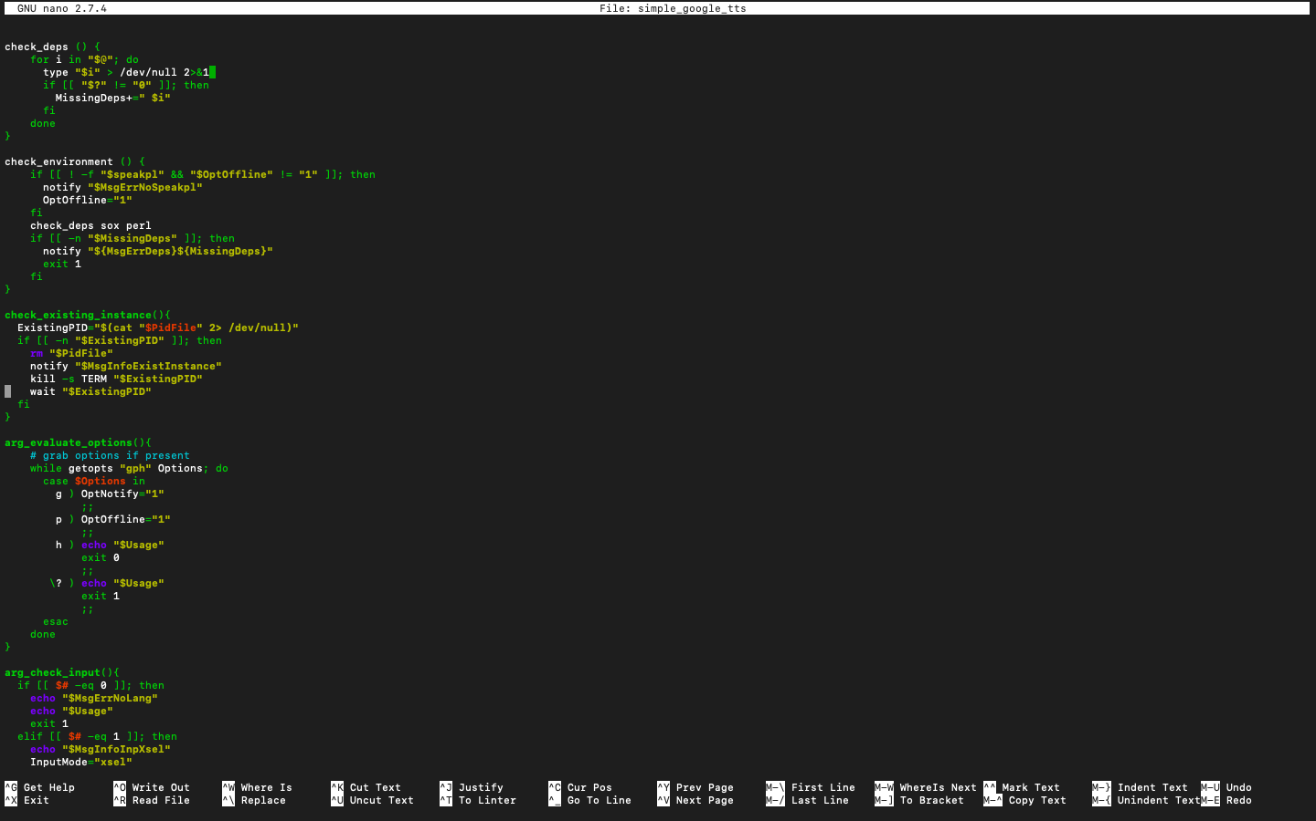
Figure 1.7(d) simple_google_tts

All the scripts combined support the architecture of text to speech conversion executing the commands based on the received text and communication with the client and server.

Bash Scripts – This part is consist of many scripts like:

- sysON
- sysOFF
- sysSTAT
- and counting

All the scripts in this component are self build and have different intentions, command converted from speech to text is used and that text is matched with the respective script so as the script can easily be executed just with a voice either inside the local area network or outside using the port forwarded by the ngrok in WAN environment.

The sample scripts for:
- sysON is shown in figure 1.8(a).
- sysOFF is shown in figure 1.8(b).
- sysSTAT is shown in figure 1.8(c).

Application Control – The motive of sysON is to communicate with arduino using serial communication and send commands to execute the respective outcome. Hence supporting the IoT technology and using relays to control appliance connected to the high voltage input coming directly from the power socket.

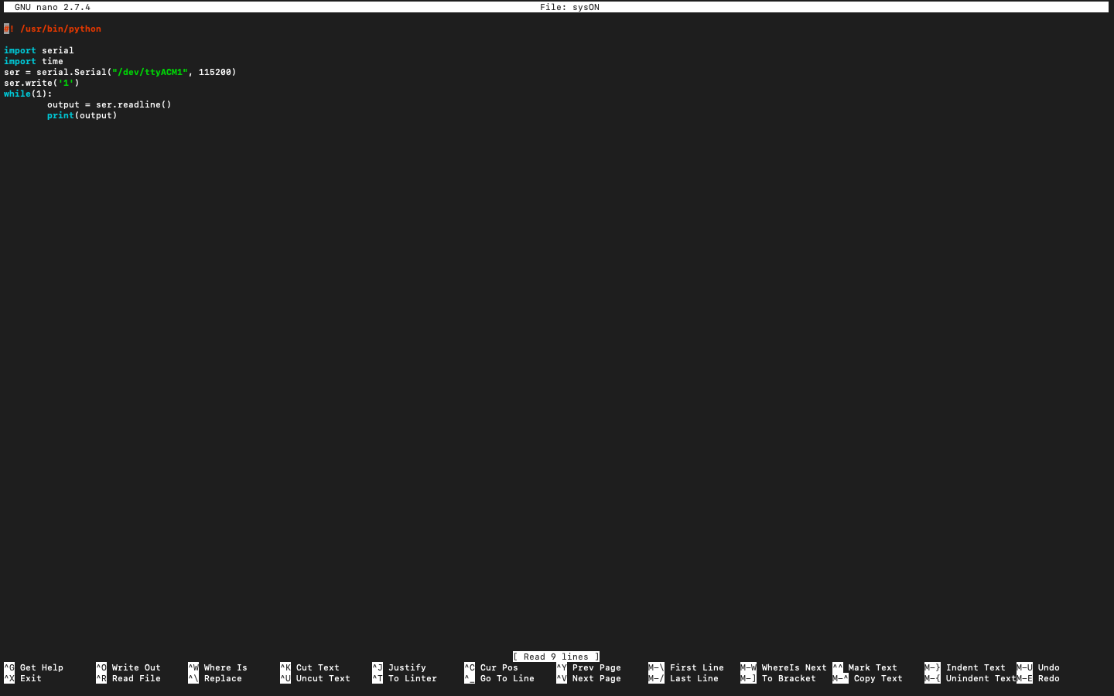
Figure 1.8(a) sysON

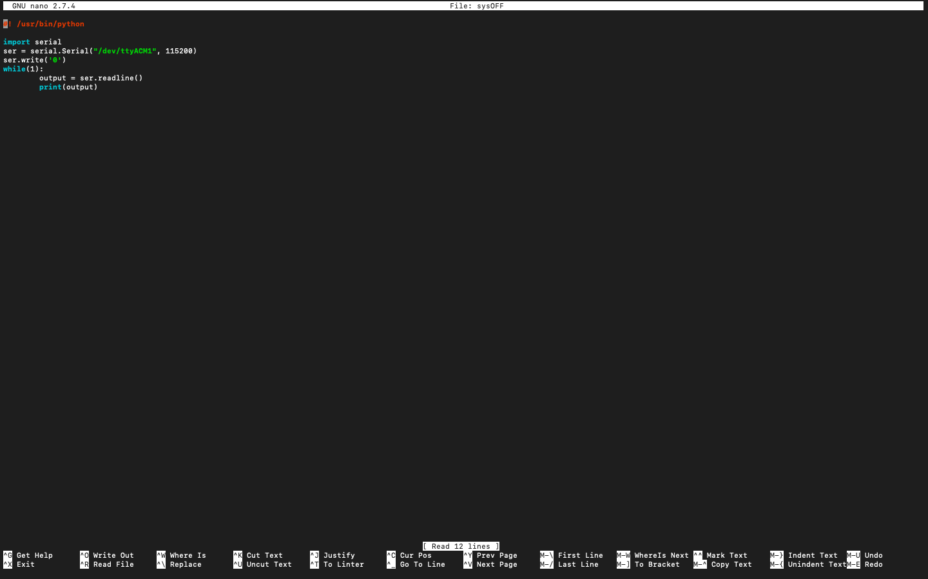
Figure 1.8(b) sysOFF

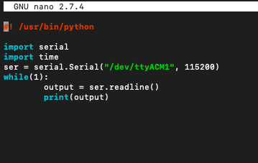
Figure 1.8(c) sysSTAT

VoiceStream script – The motive of this script is to stream the input from the microphone from the server to the target i.e client device and is achieved using commands like ‘arecord’ and ‘aplay’. Which helps is recording the sound and play it directly to the remote client as a live stream in real time, this helps in transfer of the spoken TTS(Text to speech) by the servers speaker which are attached to it using a 3.5MM jack wire.

The command is ‘arecord -D plughw:1,0 -f dat | sshpass -p "rashbir england" ssh -C '+ IP +' aplay -f dat’.

The script is made executable using same ‘chmode 755 filename’ command and the first line is added with’#!/usr/bin/python3’ which helps the terminal to recognise that the following script requires to be run in python 3 environment.

Hence the python code is used to design the script and os library is imported and os.system(‘terminal command’) is used to execute the terminal command in python environment.

Figure 1.9 shows the voiceScript designed on OS and running on OS.

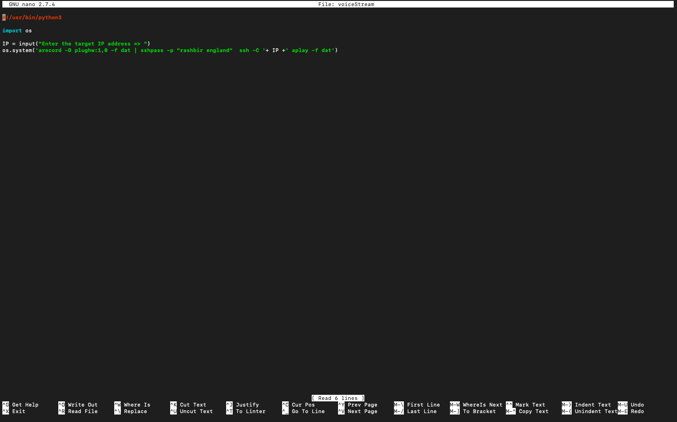
Figure 1.9 voiceStream script

Microcontroller program – This is the hard coded program uploaded on microcontroller to use its microprocessor to process the hard coded program uploaded to its memory. Here arduino uno is used and the code uploaded is shown in figure 1.10(a) and 1.10(b).

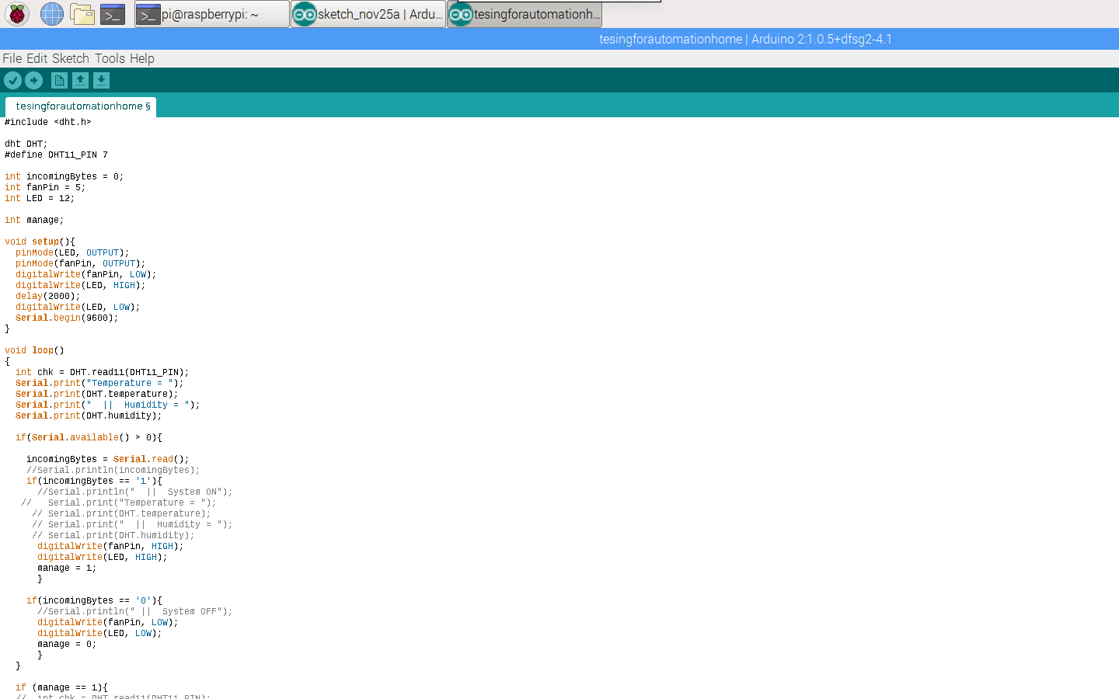
Figure 1.10(a) Arduino Code
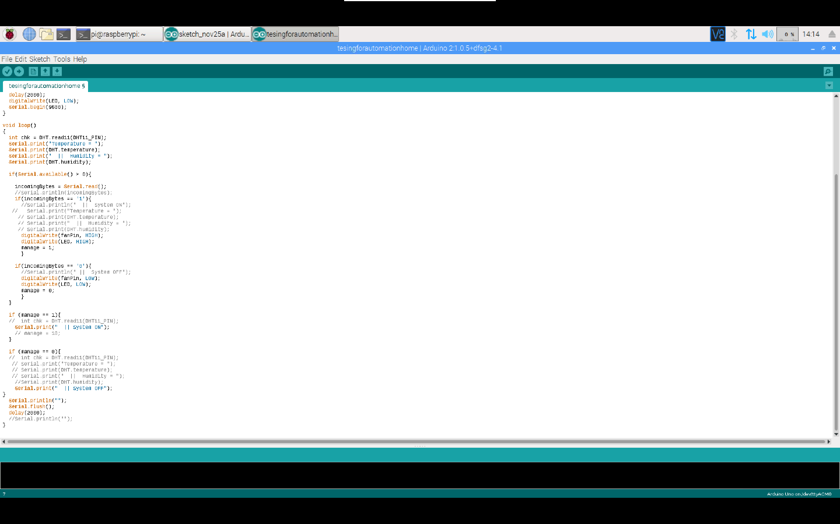
Figure 1.10(b) Ardino Code

Finally figure 1.11 shows the received screen capture in the email that shows the ngrok domain name allocated and ssh port that can be accessed.

The best thing about it is that it always changes, hence providing high security in case of domain leak the server will not be affected as it will reset the domain name. File image here received is called Network.png.

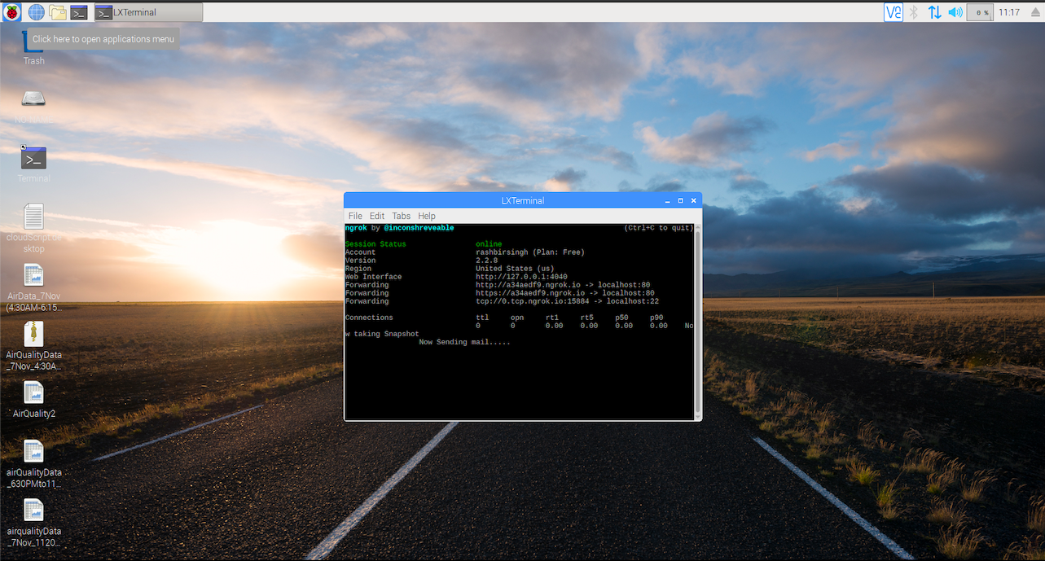
Figure 1.11 Network.png
1.4 Conclusion

The developed system is secure, supports cloud server and IoT. Allow the user to control the environments using speech in LAN or WAN environment but also allow the user to control appliance using EEG i.e controlling the environment just by thinking.

It successfully support computer vision and the developed system is robust and affective. Being running so many technologies and inter compatibility, yet it do not require high knowledge of technology and easy to learn for a non tech person. The developed system can be called an affective black box that supports simple command input and output mechanism.
References

